Electronic Circuits, POSTECH PhD Qualifying Exam(August 1st, 2013)
[1] State briefly (24점, 각 4점)
(1) In a linear time invariant circuit with the transfer function of H(s), what is the output waveform when the input is sin(wt) ? (Note, not sin(wt) u(t)),
(2) What is the most important property of active device(transistor) in signal flow?
(3) Draw a static CMOS positive-level triggered latch circuit. Use two inverters, two CMOS transmission gates and two complementary clock signals(CK, CKB).
(4) Among the BJT amplifiers(CE, CC, CB), choose the best current amplifier.
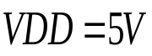
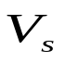
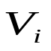
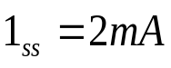
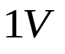

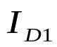
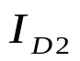
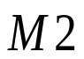
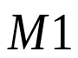
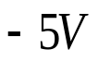
(5) Why is the DC transfer curve(Vout versus Vin) of logic gate non-linear?
(6) What is the condition to form the virtual ground in an OP amp circuit?
[2] An NMOS differential pair, (26점)
M1: uCox W/L = 2mA/V², V_{TH}=1V,
M2: uCox W/L = 8mA/V², V_{TH}=2V,
(1) Vi and Vs when I_{D1}=I_{D2} ? (13점)
(2) the ranges of Vi and Vs for I_{D2}=0 ? (13점)

[3] An NMOS amplifier for Vo/Vs is shown below. (50점)
RD1=RD2=10KΩ, R1=1KΩ, R2=9KΩ, CL=1pF,
ro=∞, gm1 = gm2 = 4mA/V, Neglect transistor’s internal parasitic capacitances
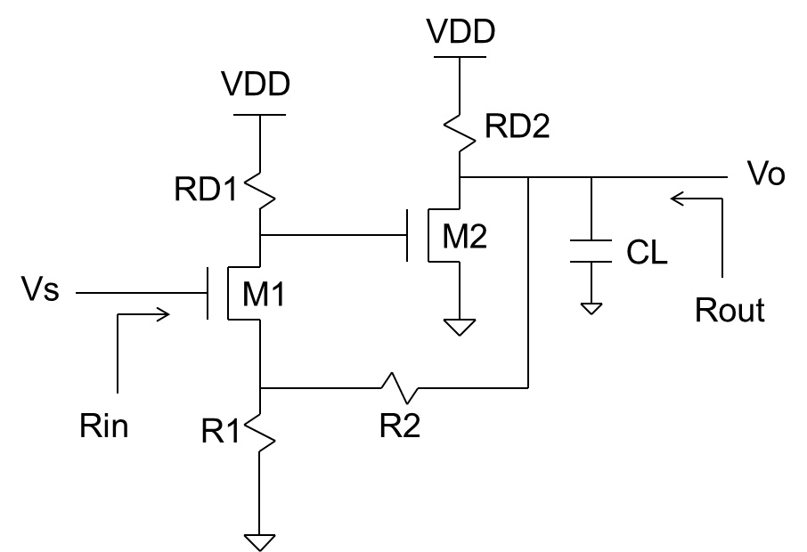
(a) Feedback type (5점)
(b) Calculate Vo/Vs (20점)
(c) Rin and Rout (10점)
(d) Unity gain bandwidth of Vo/Vs (15점)

